ELEC 3EY4 – Lab 3

Objective 1
- Reviewed lab manual.

Objective 2
- Led by Amaiam

Objective 3
- Led by Aayan
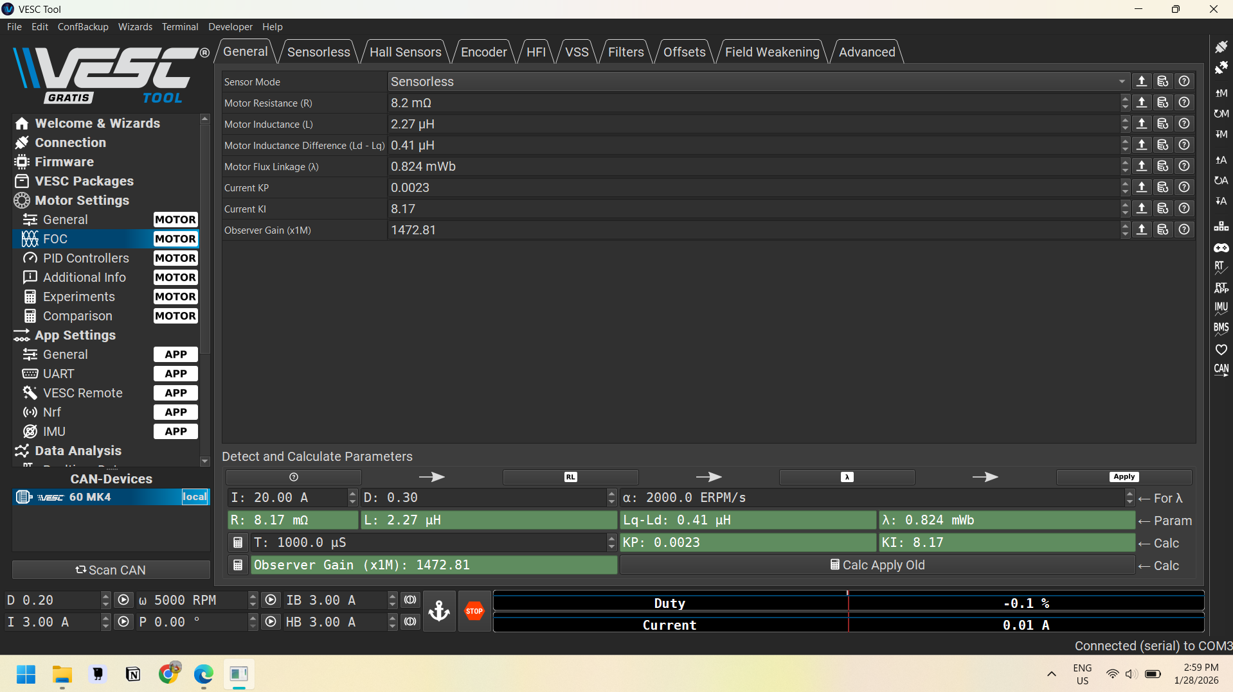

Question 1
What do those parameters represent? Why are those parameters essential to control the motor?
- Both resistance and inductance are present in the formula for calculating the electrical time constant of the motor.
- Motor Resistance proportional to the current produced relative to the volage, its the “input” to our process/control variable. The value of the resistance is dependent on the coil wire.
- Motor Inductance is dependent on the entire coil itself.
- Motor Inductance Difference
- Motor Flux Linkage represents the flux from the magnets, which interns induces current and voltage. Since it induces both voltage and current, it translates into power, P=VI, with a mechanical equivalent of P=Tw
- Kp = constant for the proportional part of PID
- Ki = constant for the integral part of PID
- D = duty cycle of the voltage

Objective 4
- Led by Jasmine

Question 2
Explain the importance of PID speed control parameters in relation to the operation of McMaster AEV?
P: The proportaional speed control parameter (Kp) impacts how much current (present) error will affect the motor’s current. Increasing Kp results in a decreased s.s. error but increases the overshoot. A good Kp will minimize the s.s. error, without causing the AEV’s motor to be too unstable (oscillating way higher/lower than the desired speed).
I: The integreal speed control parameter (Ki) uses previous error and can get rid of s.s. error completely by integrating all the past error. Increasing Ki however increases the overshoot and settling time, meaning it will take longer for the motor to reach steady-state. A good Ki will eliminate or minimize s.s. error, without causing the motor to take too long to reach the desired speed.
D: The derivative speed control parameter (Kd) uses the rate that the error is changing. Increasing Kd has no impact on the s.s. error. It does, however, decrease the overshoot and settling time. A derivative controller is very susceptible noise because it would cause the error to change rapidly. Thus, the Kd cannot be too high. It is still very helpful to deal with any overshoot, or long settling time that are caused by the integral and proportional controller.
All three are necessary to ensure the motor runs at the desired speed as quickly as possible and can adapt to external circumstances such as terrain changes.

Question 3
2500 RPM | 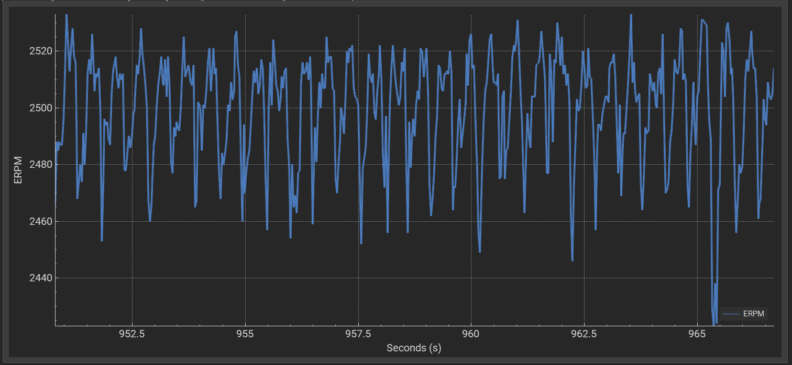  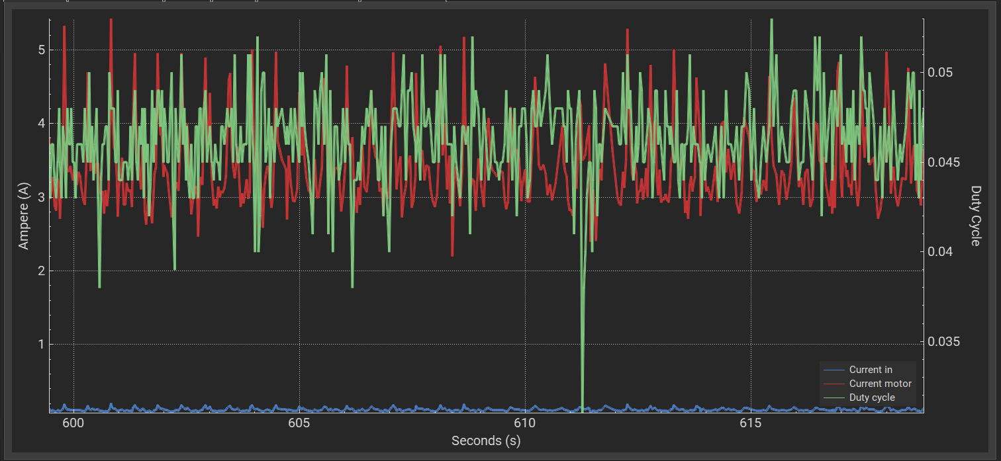  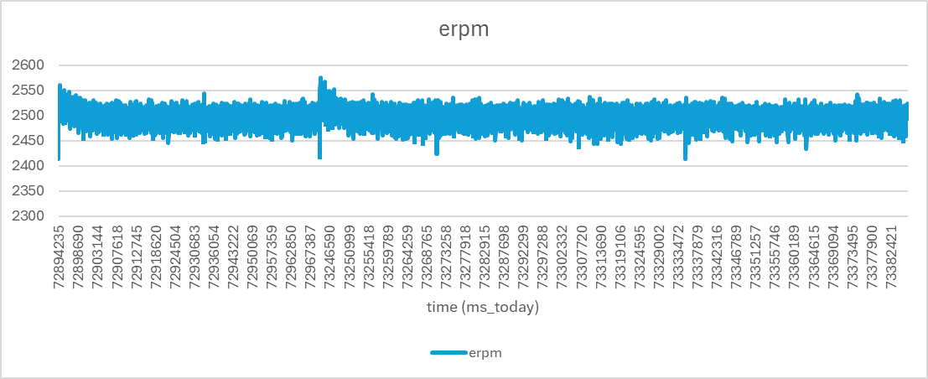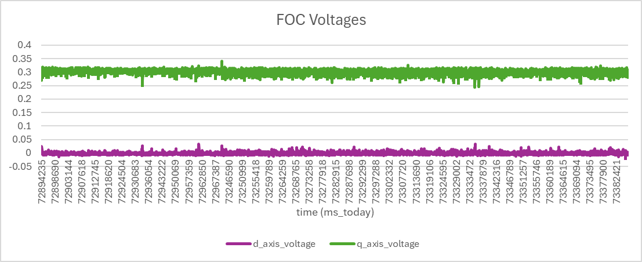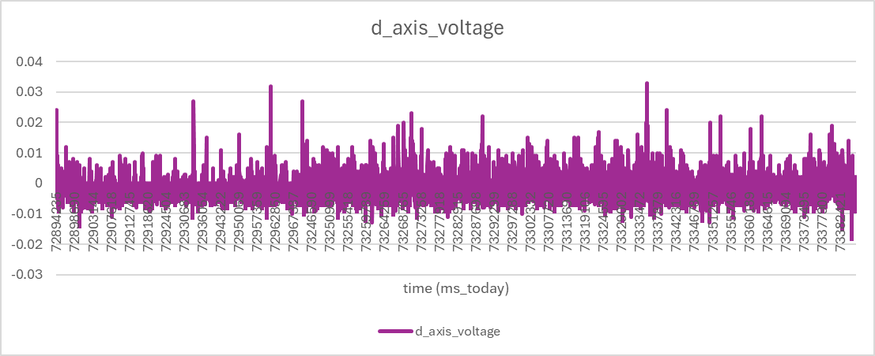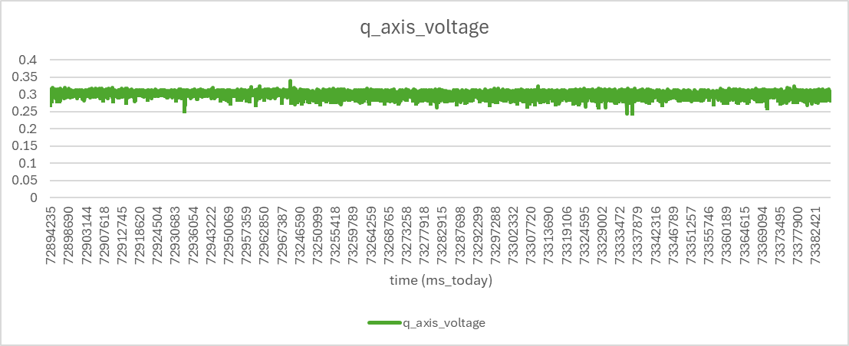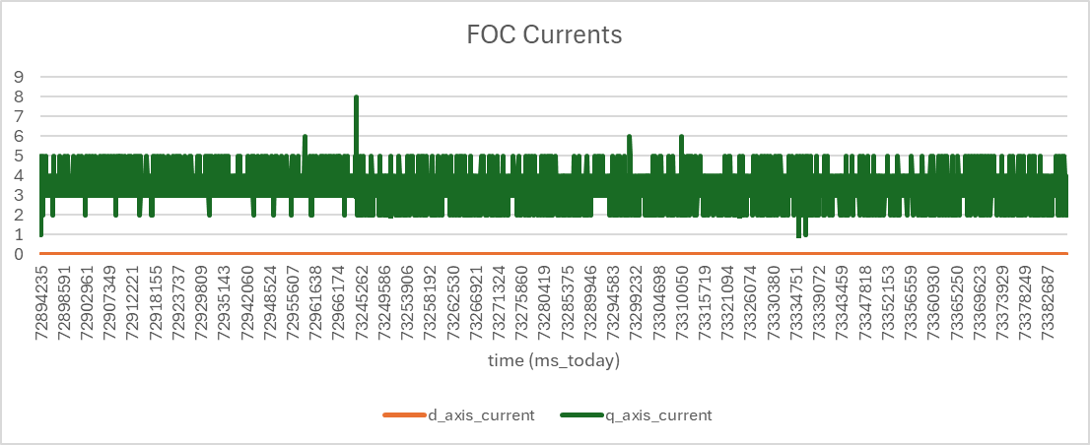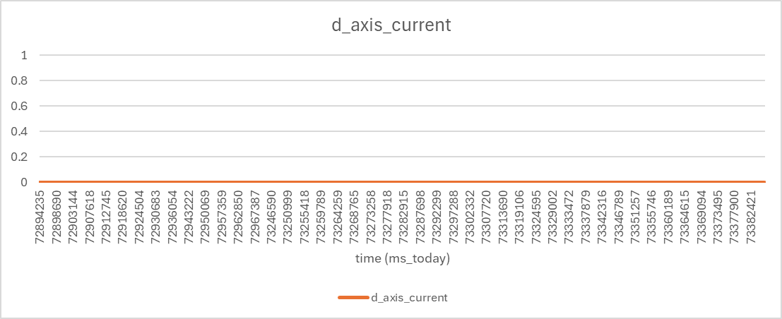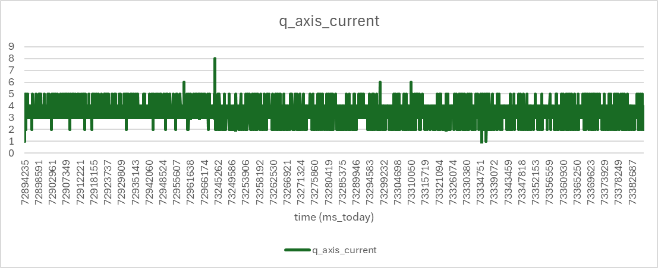
5000 RPM | 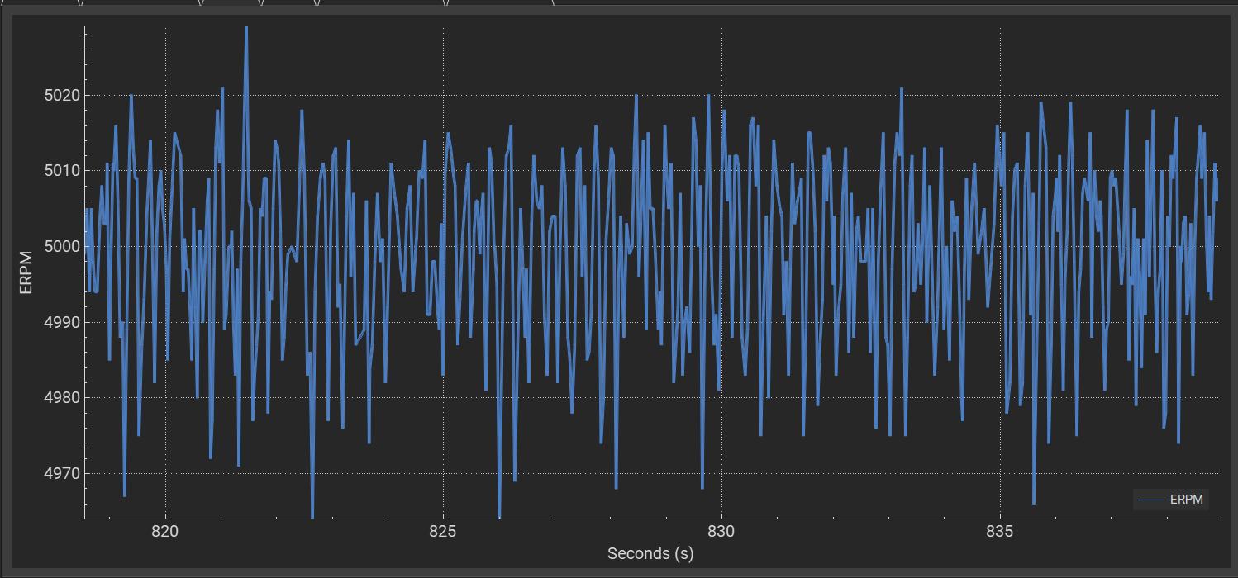  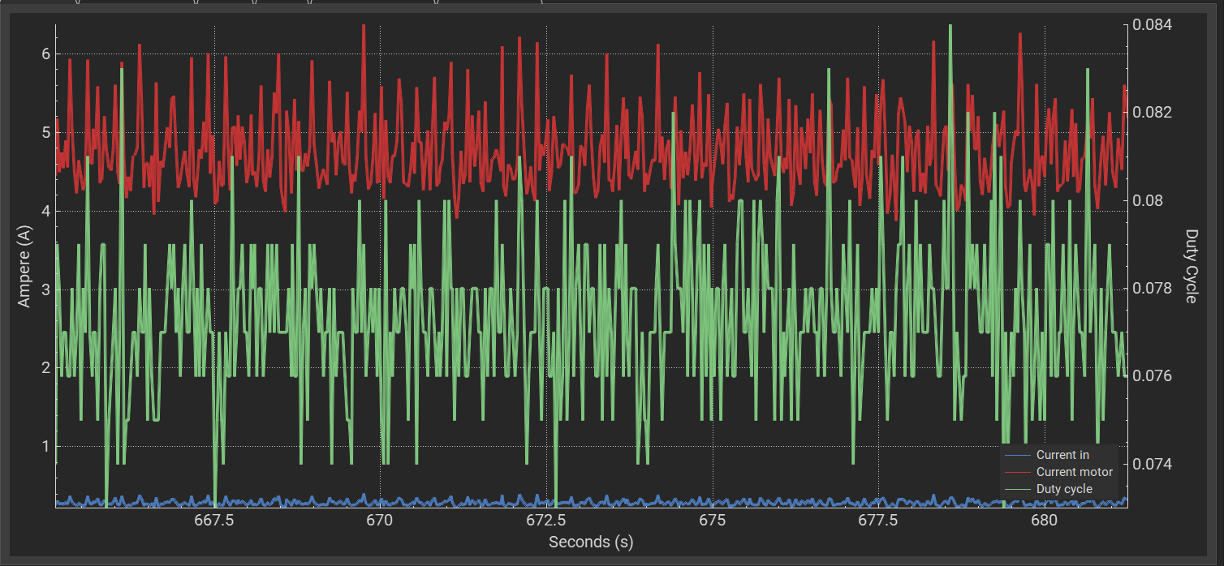  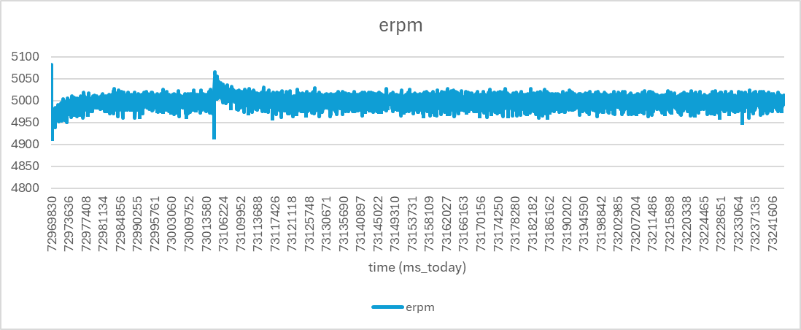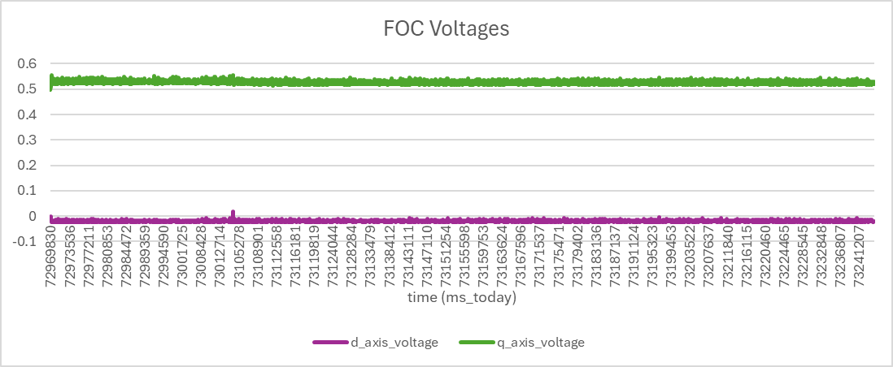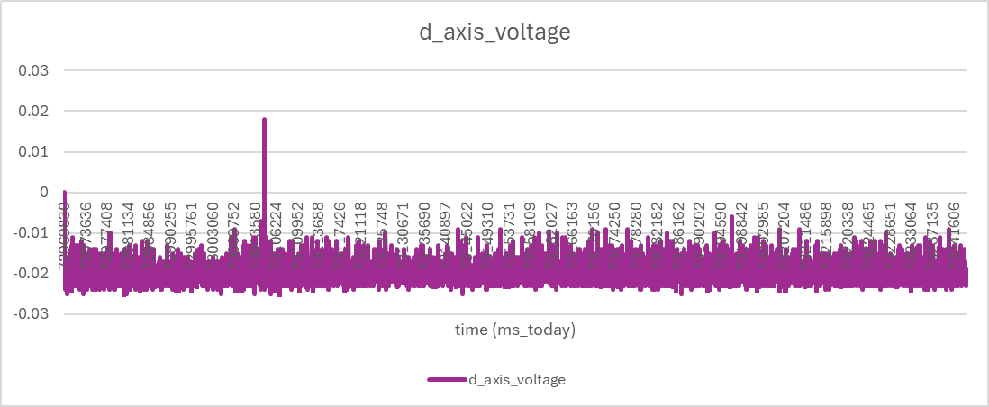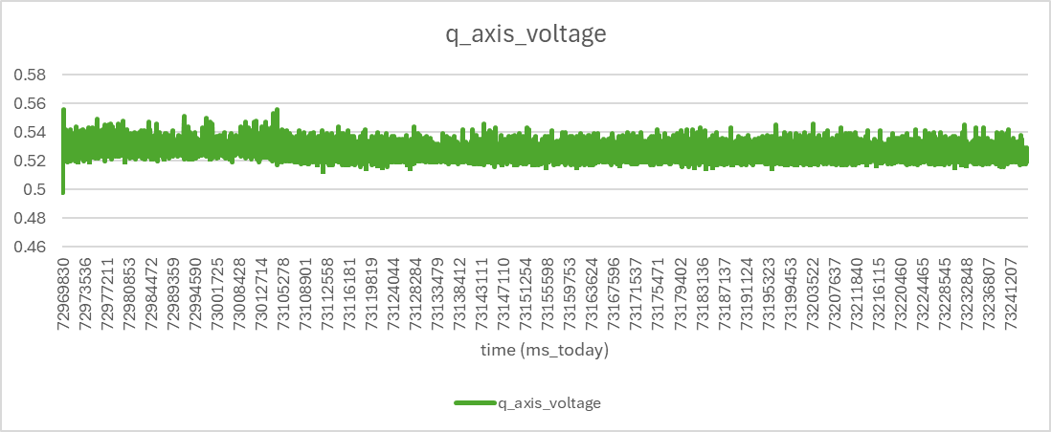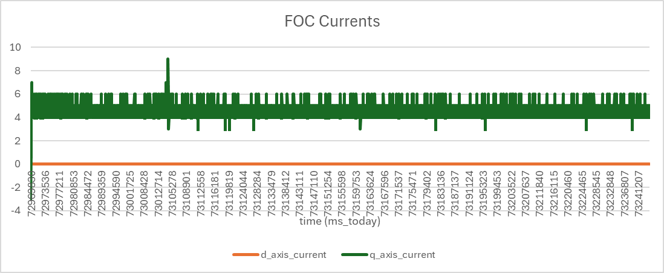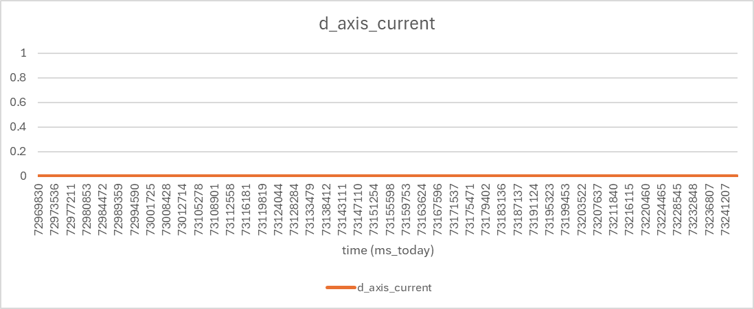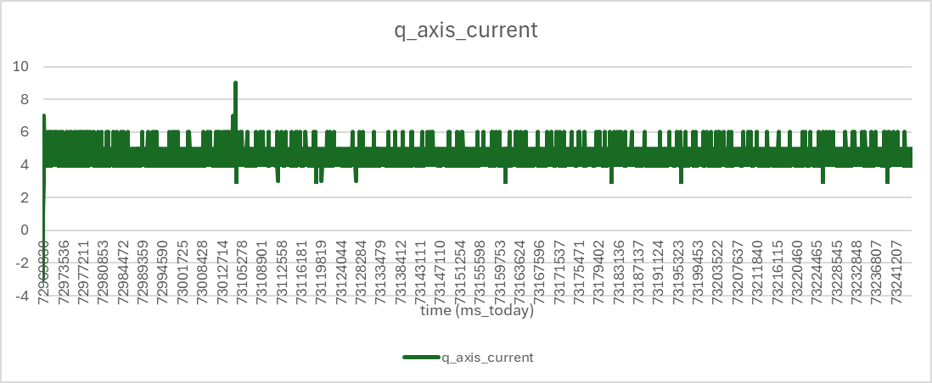
7500 RPM | 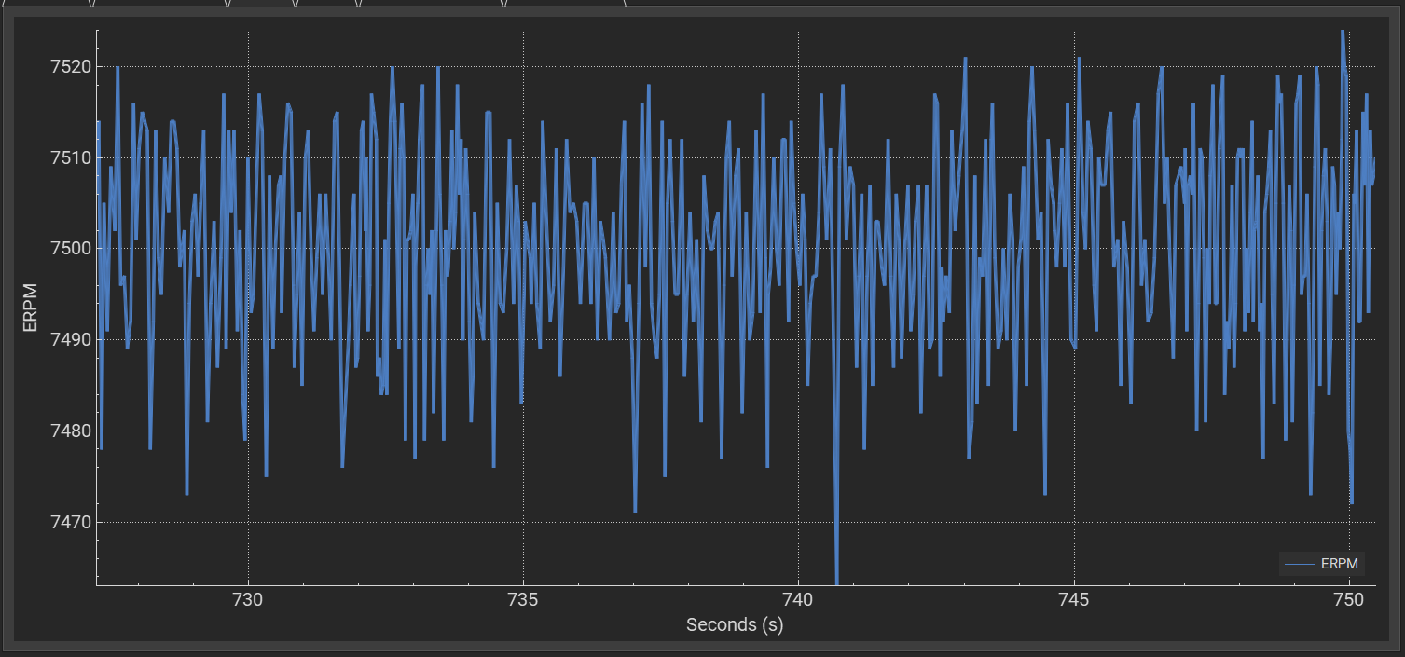  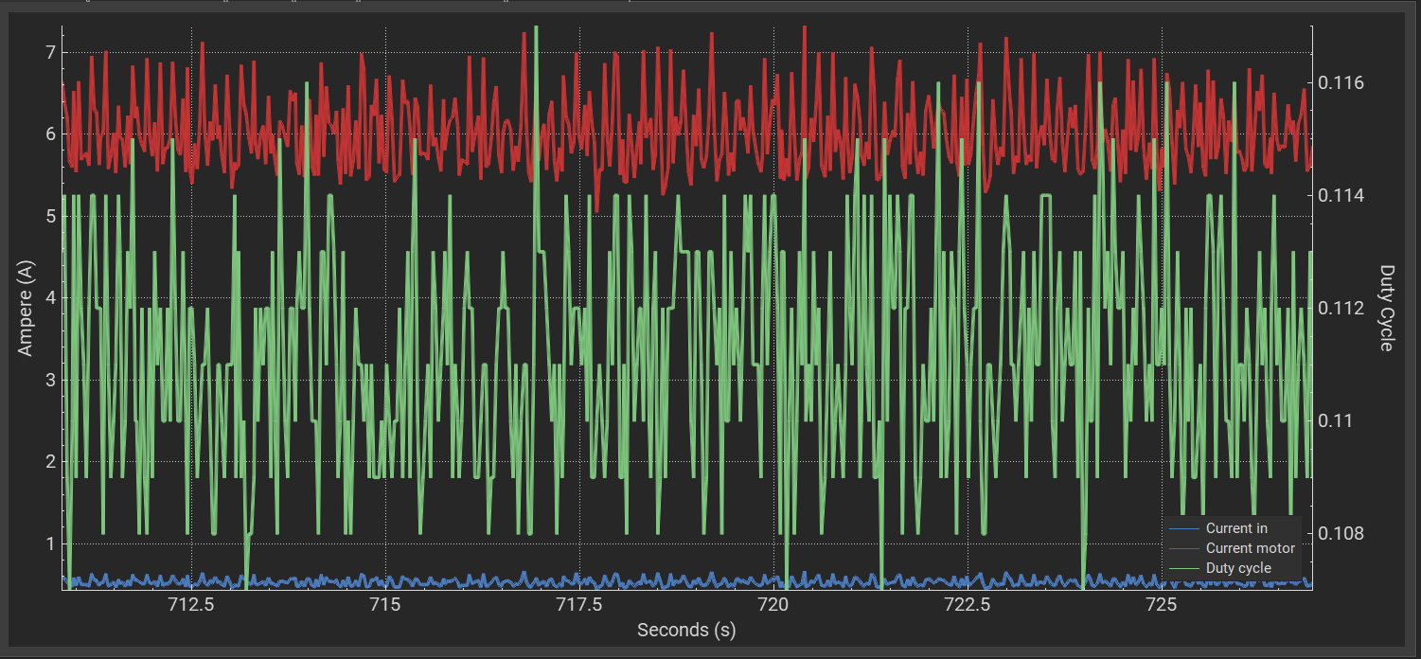  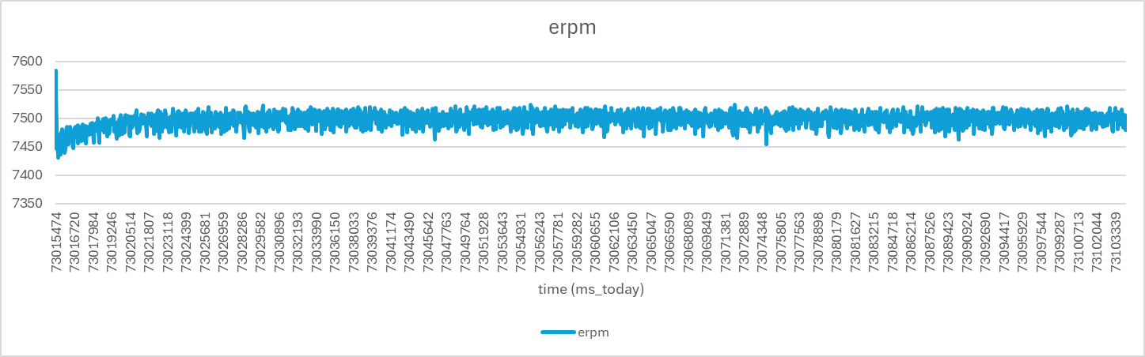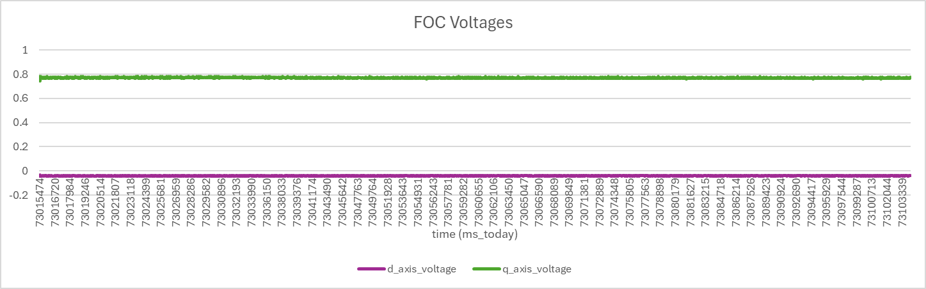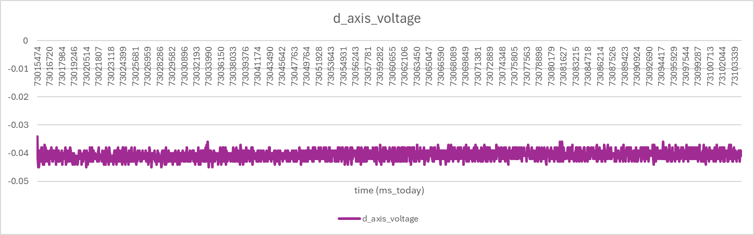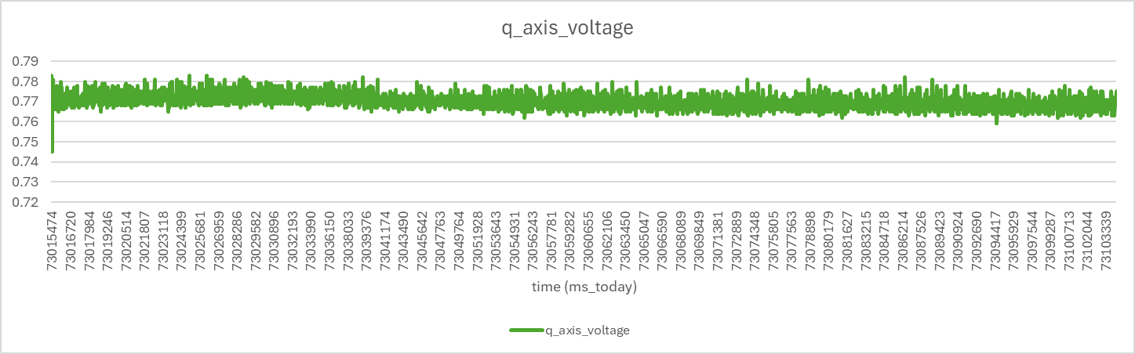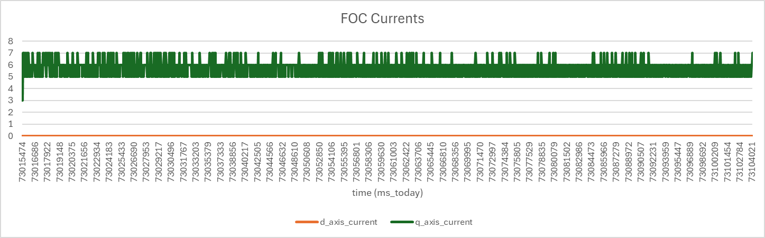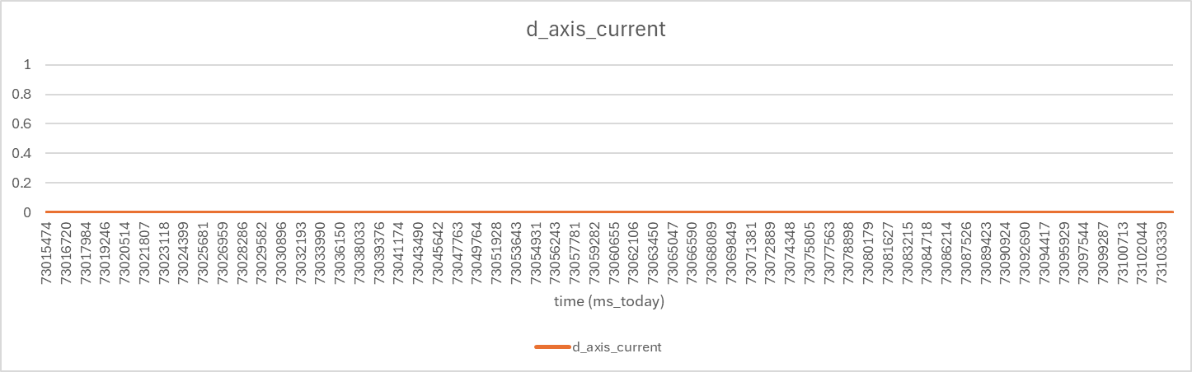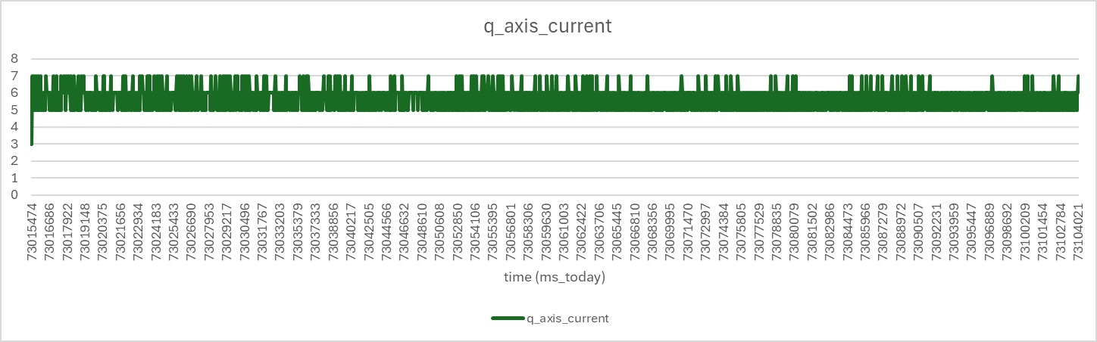

Question 4
0.10 | 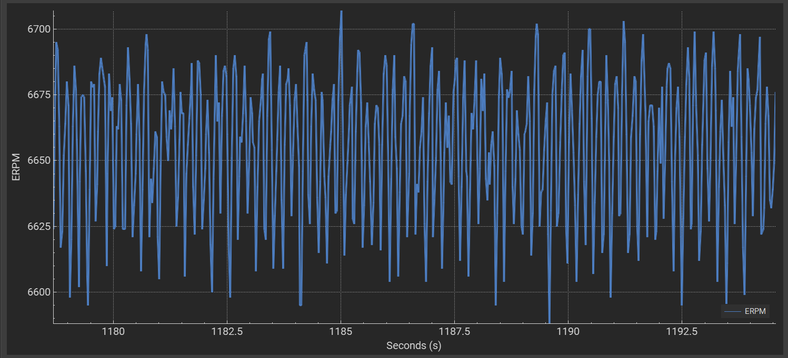  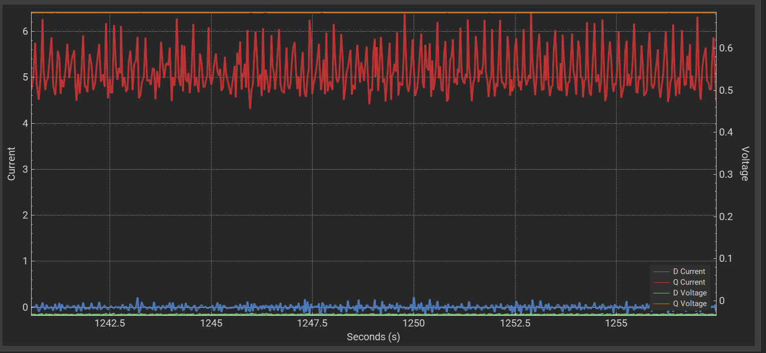  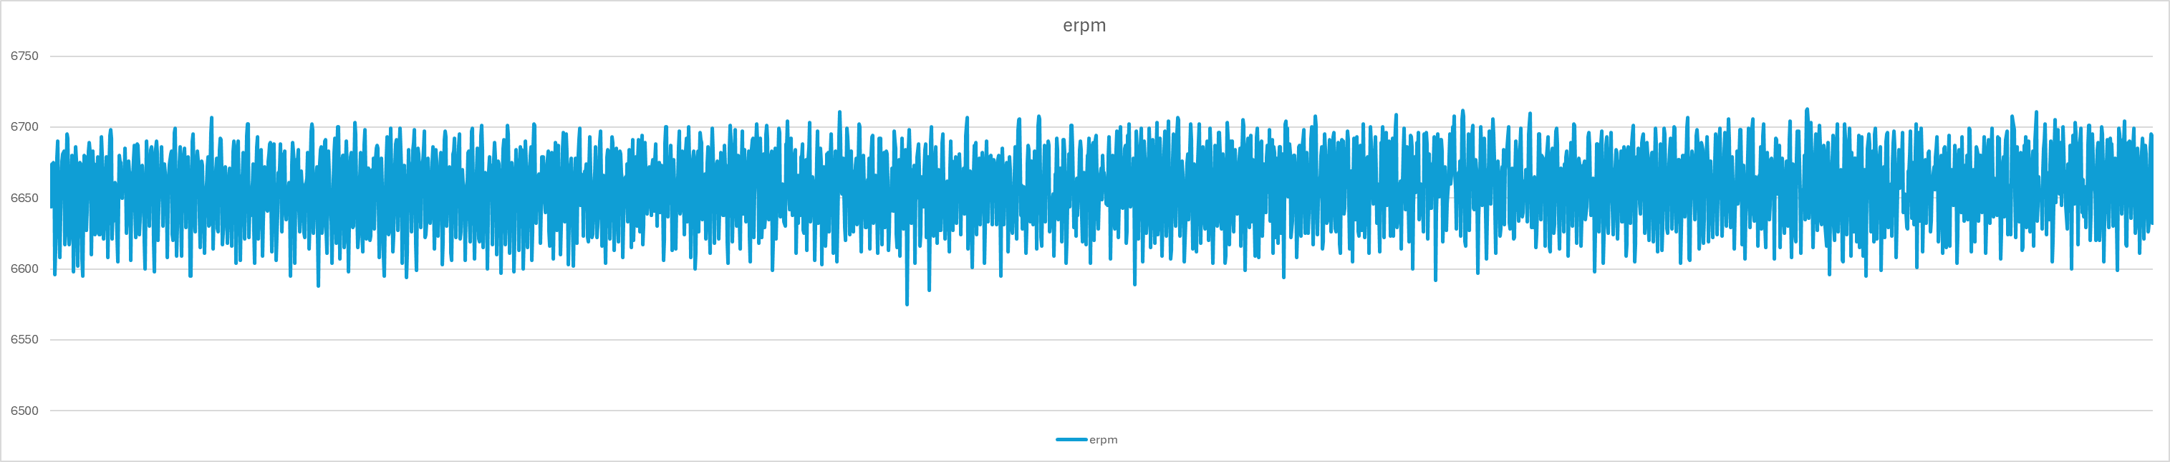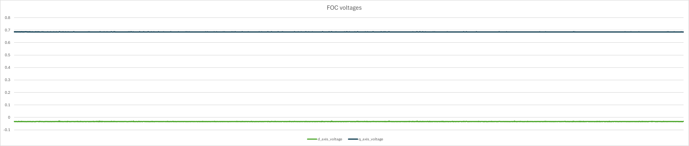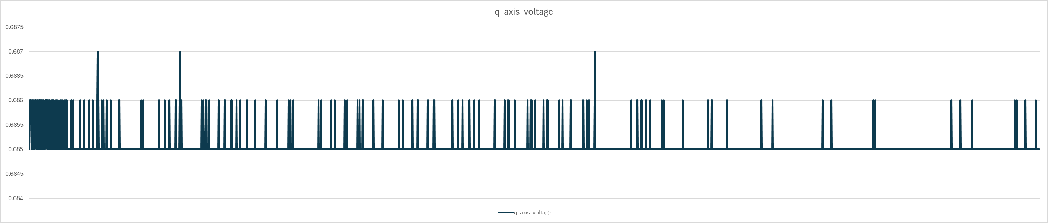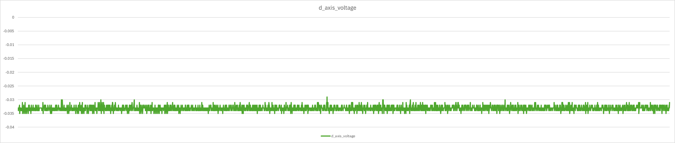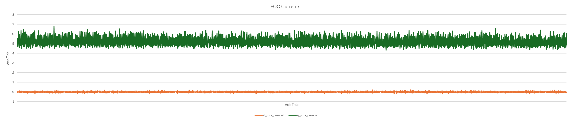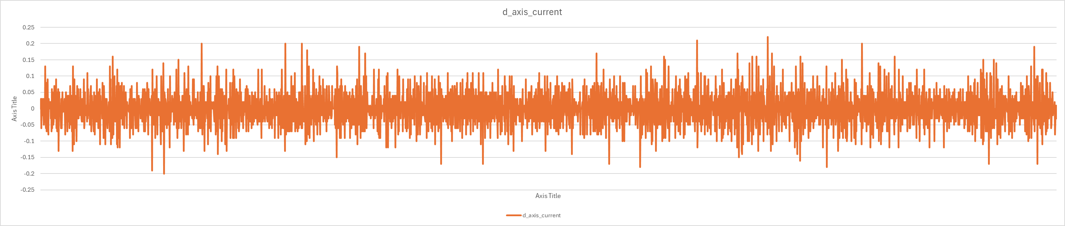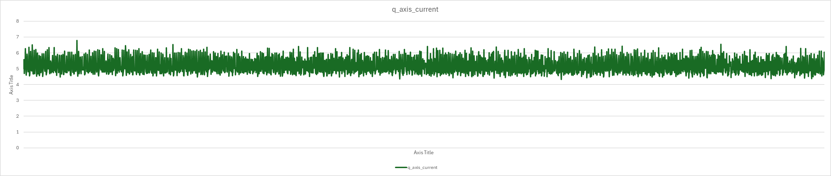
0.15 | 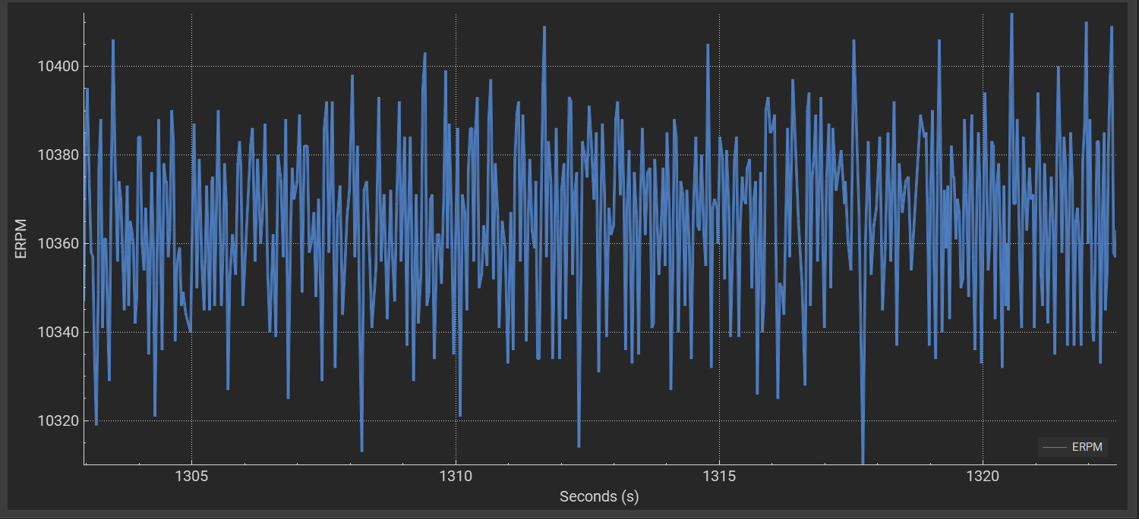  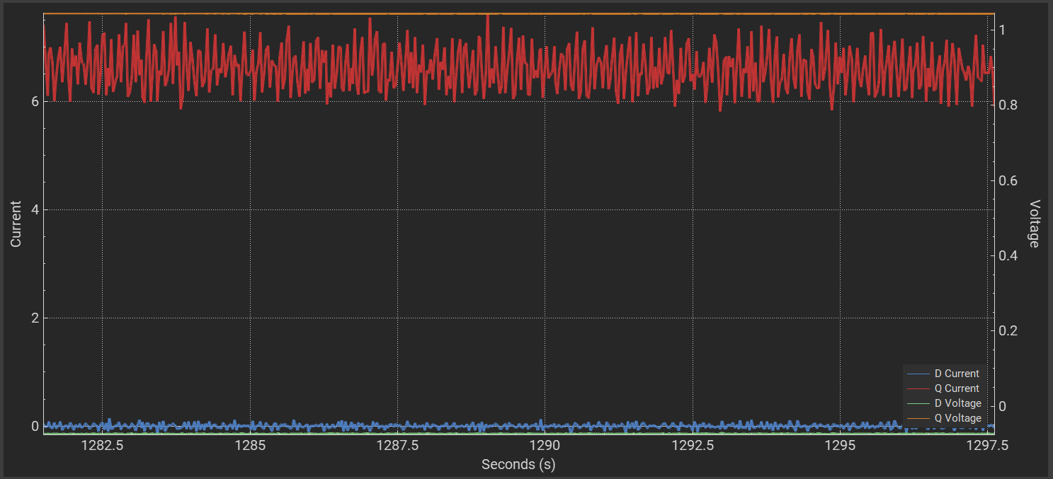  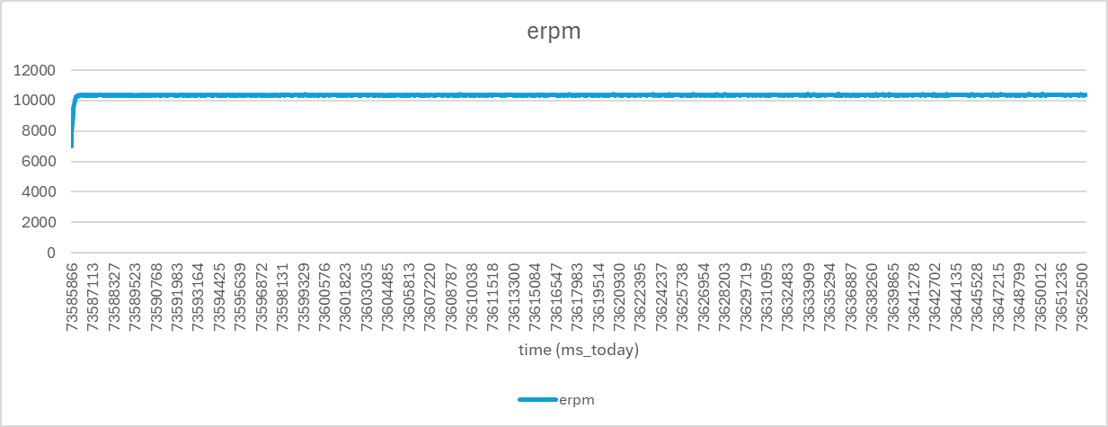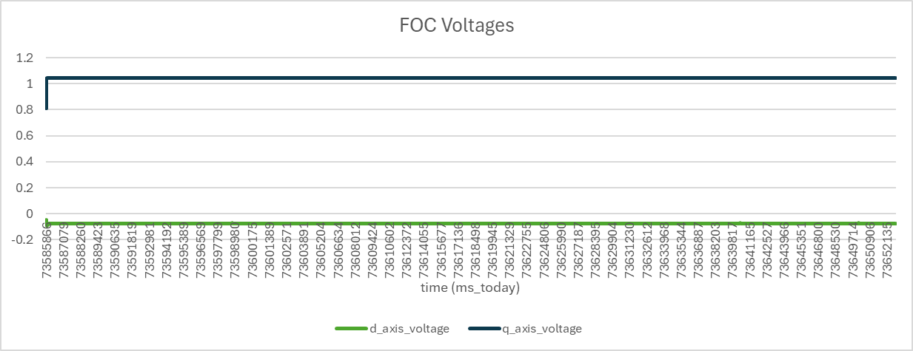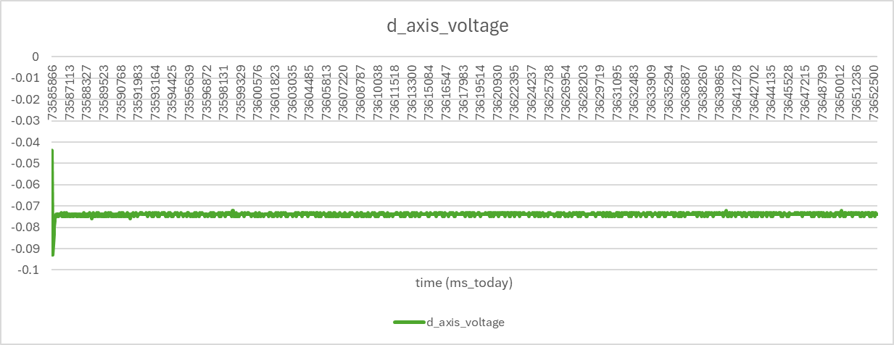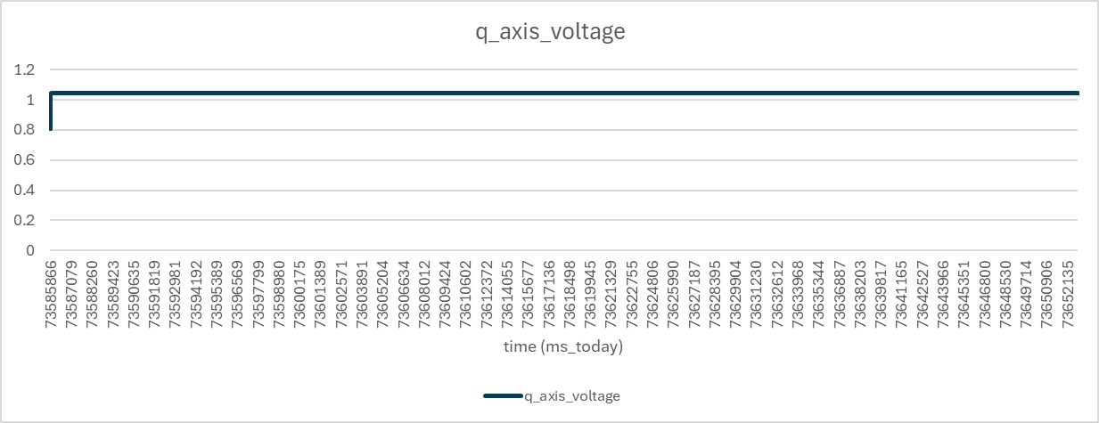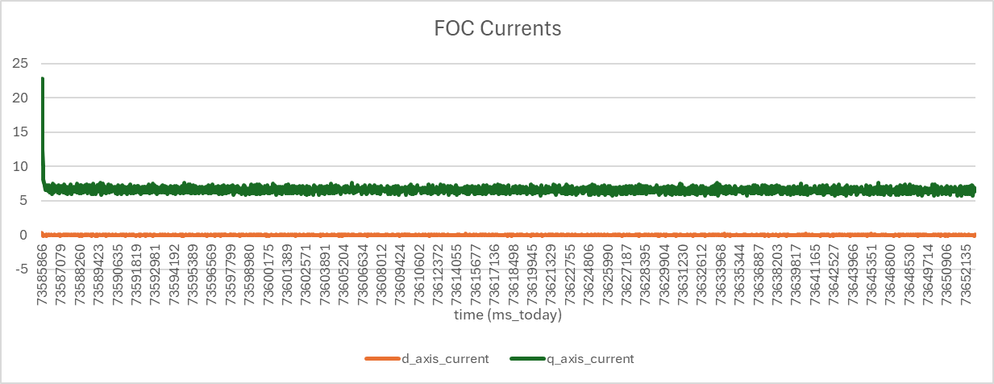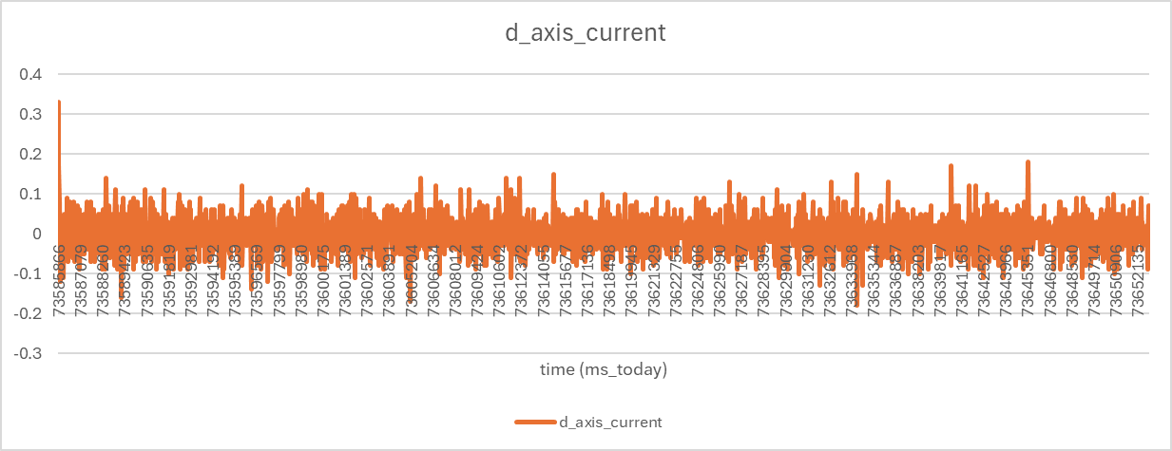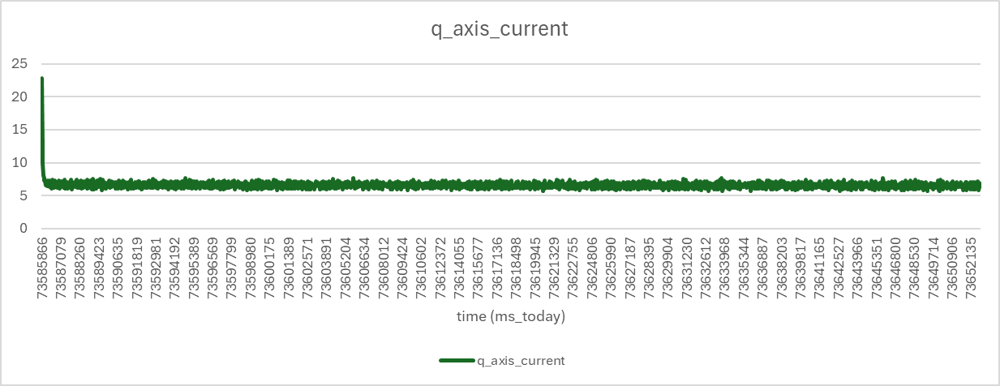
0.2 | 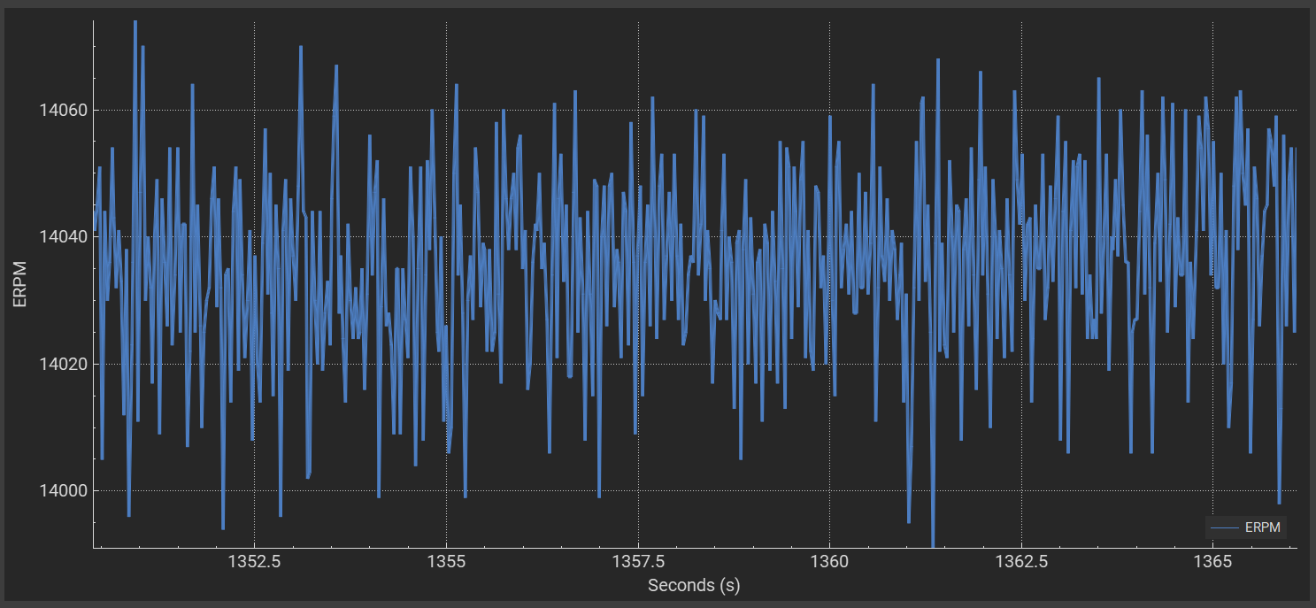  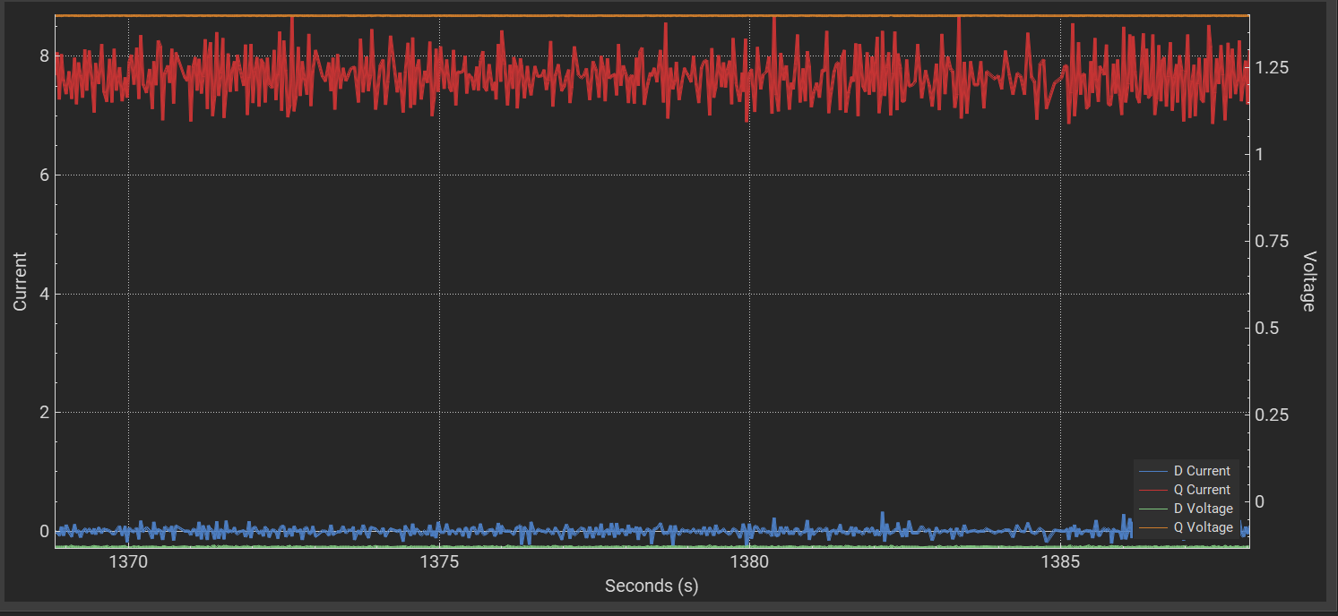  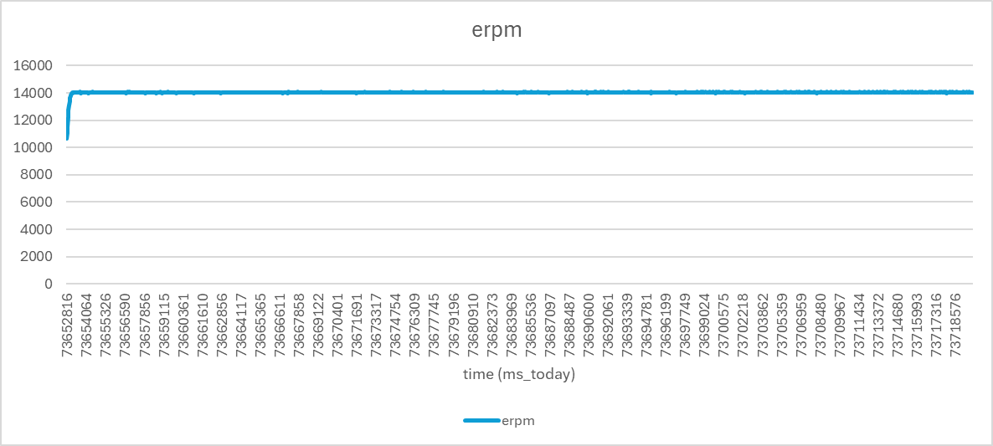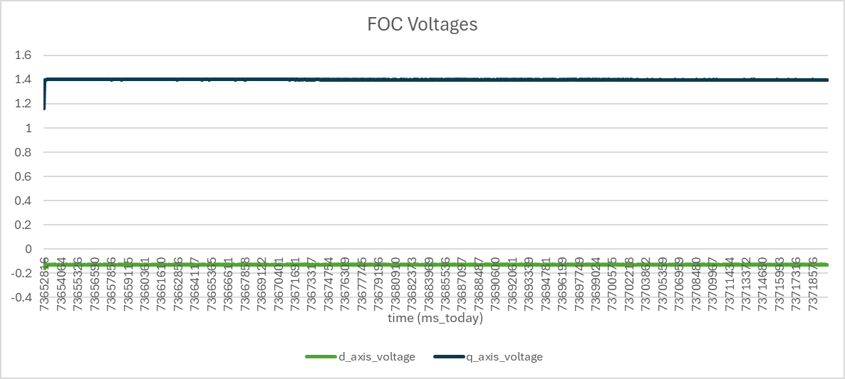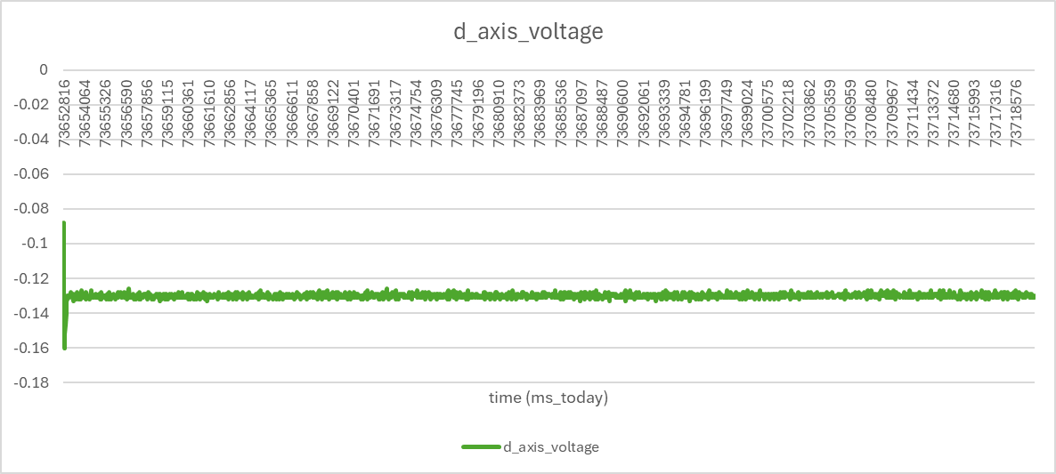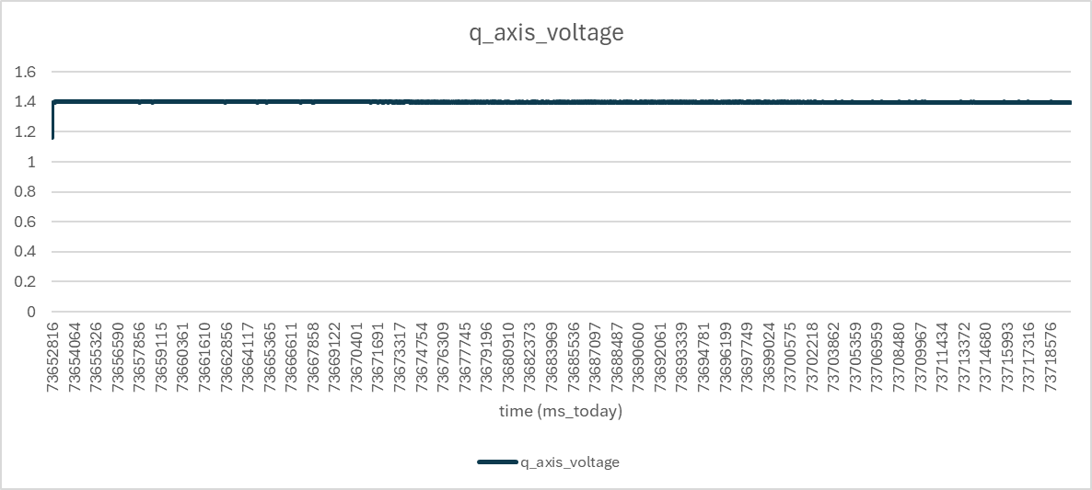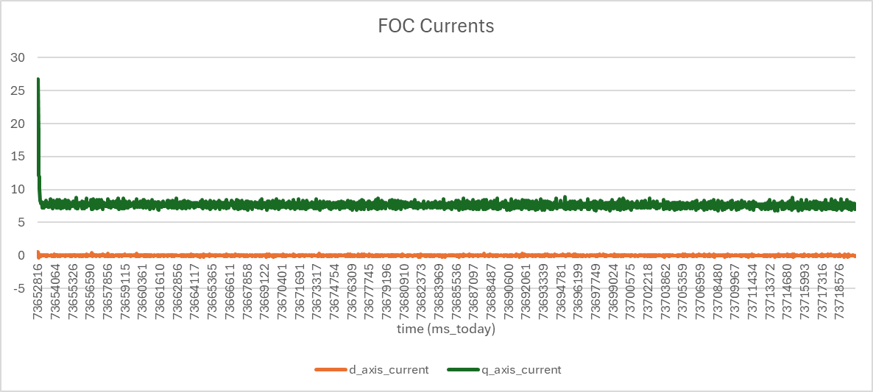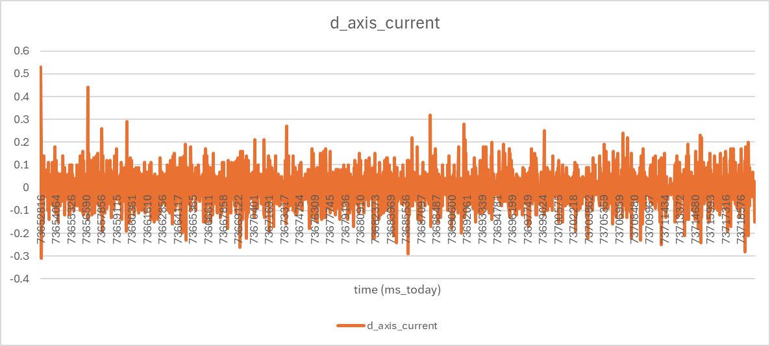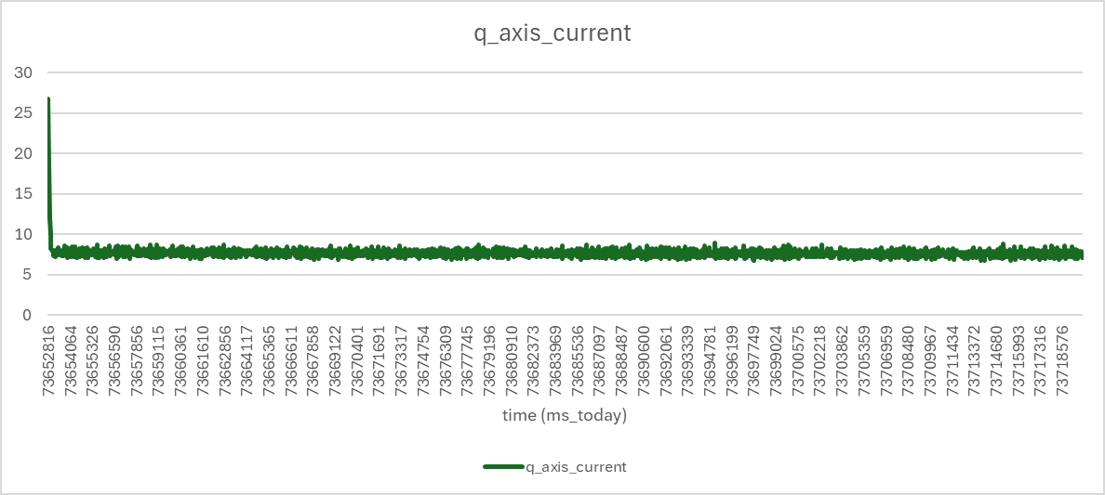

Question 5
What difference do you observe between the operations with the speed command and duty cycle command? Explain the difference using the real-time voltage, current, and speed waveforms
- Running the duty cycle command led to the AEV running a lot more smoother than when the speed command was applied.
- This can be visually seen from the graphs of the duty cycle and speed command. The duty cycle graph shows a lot less noise than the speed command graph, resulting in smoother operations.

Question 6
What is the definition of the d and q-axis currents? Why is the d-axis current always zero?
Iq is perpendicular to the rotor flux, and thus produces torque in the system. Id is parallel to the rotor flux and thus produces magnetic flux.
When phase currents are in phase with the back emf produced by the magnets, the currents are called q-axis currents (where q stands for quadrature -> 90 degrees). The d-axis current is 90 degrees shifted compared to the q-axis current, and is aligned with the actual field of the rotor itself.
Iq and Id, in essence, represent the proportion of current that is used for torque vs adding magnetic flux. When Id is zero, all of the current is being used to produce torque. We don't need additional magnetic flux, nor do we want to oppose the rotor’s flux. We set the d-axis current to 0 to thus maximize the overall torque in this case.

